Task1:Website analysis
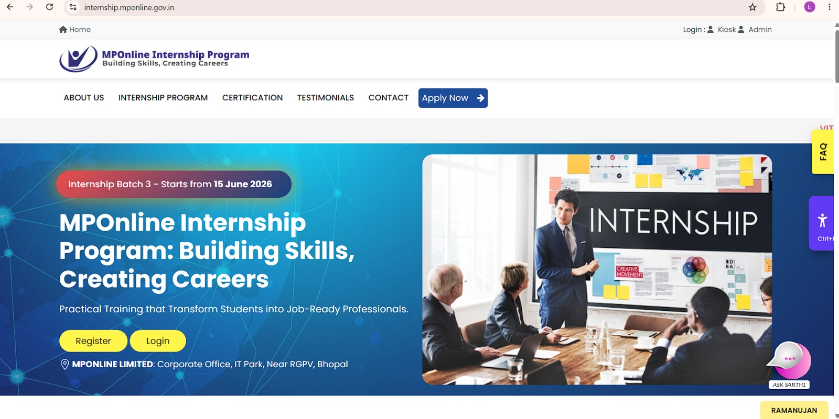
Figure 1HOMEPAGE
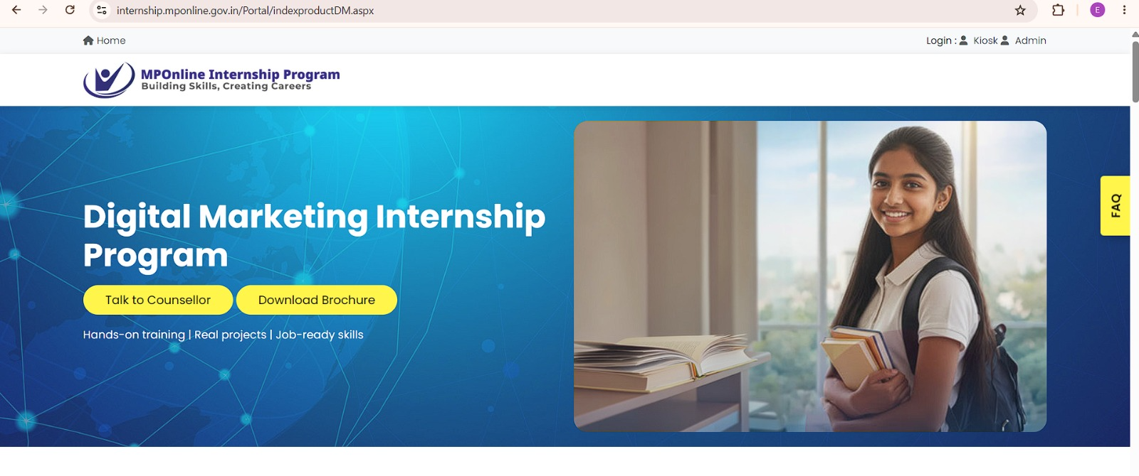
Figure 2DIGITAL MARKETING INTERNSHIP
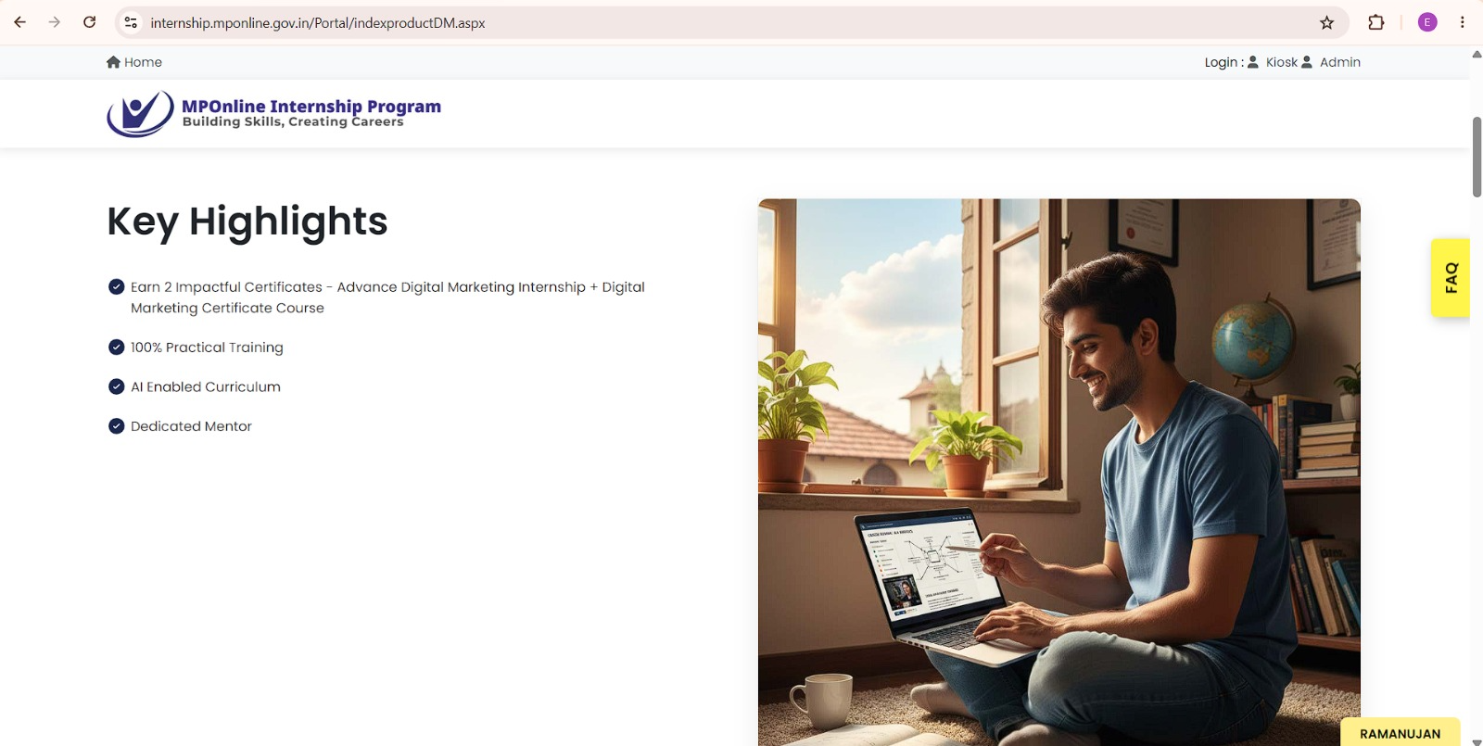
Figure 3KEY HIGHLIGHTS OF THE INTERNSHIP
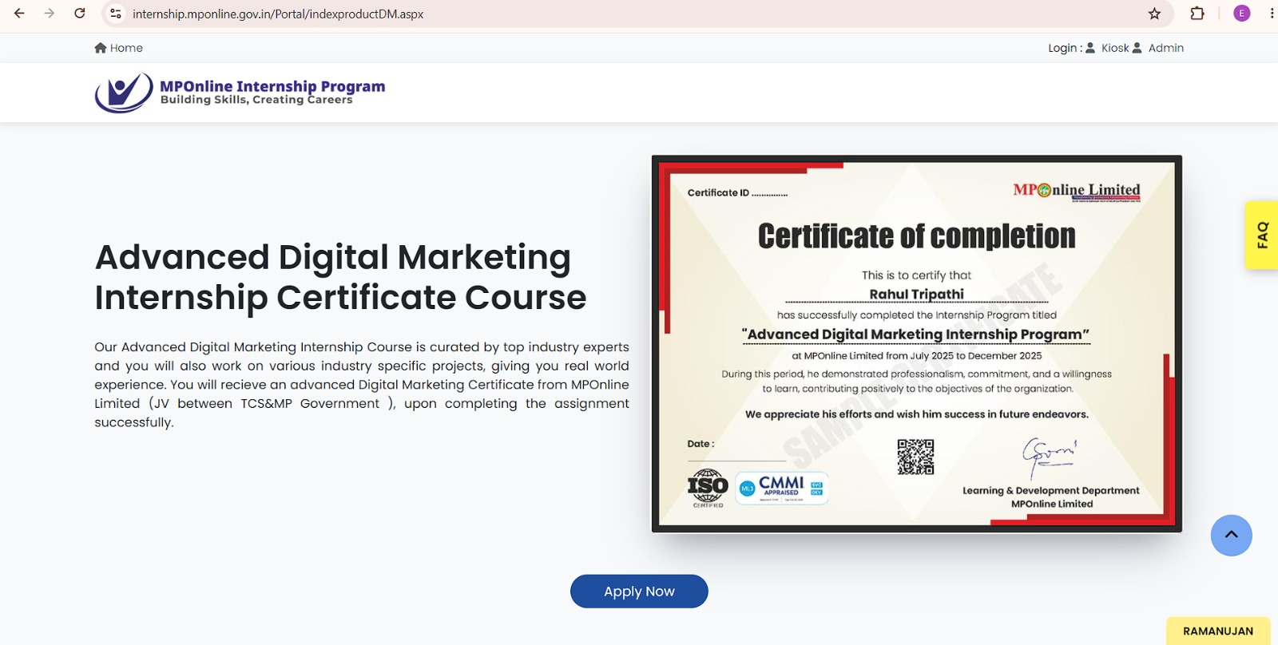
Figure 4INTERNSHIP BENEFITS
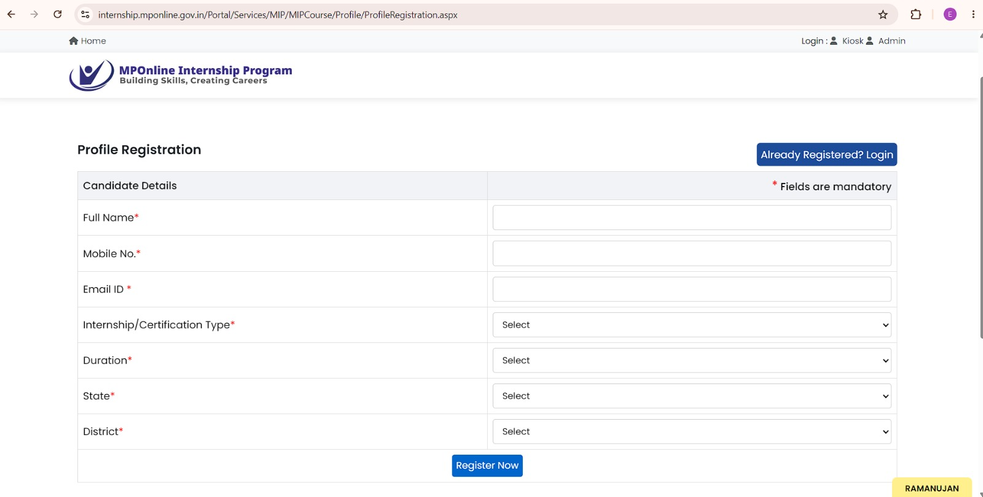
Figure 5REGISTERATION FORM

Task 2:
Buyer Personas
Persona 1 – Engineering Student
Field | Details
Name | Rahul Sharma
Age | 20 Years
Location | Bhopal, Madhya Pradesh
Education | B.Tech 3rd Year
Goals | Gain practical experience, build a strong resume, improve placement opportunities
Interests | Coding, Artificial Intelligence, Technology, Hackathons
Online Behavior | Watches technical videos on YouTube, follows coding communities, searches internships on Google
Pain Points | Lack of industry exposure, high competition during placements, limited practical skills
Preferred Social Platforms | LinkedIn, Instagram, YouTube

Persona 2 – Final Year Graduate
Field | Details
Name | Priya Verma
Age | 22 Years
Location | Indore, Madhya Pradesh
Education | BBA Final Year Student
Goals | Secure an internship certificate, improve employability, gain professional experience
Interests | Business, Marketing, Career Development, Personal Growth
Online Behavior | Uses LinkedIn daily, follows career influencers, participates in placement groups
Pain Points | Limited work experience, uncertainty about career options, interview anxiety
Preferred Social Platforms | LinkedIn, Instagram, Facebook

Persona 3 – Job Seeking Fresher
Field | Details
Name | Aman Singh
Age | 23 Years
Location | Gwalior, Madhya Pradesh
Education | B.Sc Graduate
Goals | Get first job, gain industry exposure, improve professional skills
Interests | Career Growth, Government Opportunities, Online Learning, Skill Development
Online Behavior | Searches job portals regularly, attends online webinars, watches career guidance videos
Pain Points | Lack of experience, fewer interview opportunities, difficulty standing out from other candidates
Preferred Social Platforms | LinkedIn, Facebook, YouTube

These buyer personas represent the primary audience segments for the MPOnline Internship Program. Understanding their goals, behavior, and challenges helps create targeted marketing campaigns that improve engagement and application rates

Part 3: Social Media Marketing Strategy
Objective
The objective of the social media campaign is to increase awareness about the MPOnline Internship Program, generate student registrations, and encourage internship applications.

Platforms Used
1. Instagram
- Reach college students
- Reels and Stories
- Student engagement
2. Facebook
- Reach students and fresh graduates
- Community building
- Lead generation
3. LinkedIn
- Professional audience
- Internship promotion
- Career-focused content

Content Mix Strategy
Content Type | Percentage
Informational Posts | 30%
Career Tips | 20%
Internship Benefits | 20%
Student Testimonials | 15%
Success Stories | 10%
Reels/Short Videos | 5%

Content Frequency Plan
Content Type | Frequency | Objective
Reels | 3 per week | Increase reach
Static Posts | 4 per week | Educate students
Stories | Daily | Improve engagement
Testimonials | 2 per week | Build trust
Career Tips | 2 per week | Provide value
30-Day Social Media Calendar
Week | Theme | Content
Week 1 | Awareness | Internship Benefits, Program Introduction
Week 2 | Education | Career Tips, Skill Development
Week 3 | Trust Building | Student Testimonials, Success Stories
Week 4 | Conversion | Registration Reminders, Apply Now Posts

10 Sample Post Ideas

Post 1

Topic: Why Every Student Needs an Internship

Post 2

Topic: Top 5 Skills Employers Look For

Post 3

Topic: Benefits of the MPOnline Internship Program

Post 4

Topic: Resume Tips for Students

Post 5

Topic: Student Success Story

Post 6

Topic: Common Interview Mistakes

Post 7

Topic: Internship vs REGULAR COLLEGE

Post 8

Topic: A Day in the Life of an Intern

Post 9

Topic: How Internships Improve Employability

Post 10

Topic: Last Date to Apply – Register Now

The social media strategy focuses on awareness, engagement, trust-building, and conversions. By using Instagram, Facebook, and LinkedIn with a balanced content mix, the campaign aims to maximize student registrations and internship applications.

Part 4: Meta Ads Campaign Planning
Campaign Objective : Lead Generation
Why Lead Generation?
The goal of the MPOnline Internship Program is to collect registrations and internship applications from students. Therefore, Lead Generation is the most suitable Meta Ads objective.
Target Audience:
Parameter | Details
Age Group | 18–25 Years
Gender | Male & Female
Location | India (Primary Focus: Madhya Pradesh)
Education | Students, Final Year Students, Graduates
Languages | English, Hindi
Device | Mobile & Desktop

Audience Interests
Target users interested in:
- Engineering Students
- College Students
- Internship Opportunities
- Career Development
- Digital Marketing
- Software Development
- Placement Preparation
- Professional Skills
- Resume Building

Ad Creative 1
Primary Text
Looking to gain real-world experience and boost your career?
Join the MPOnline Internship Program and gain practical industry exposure, valuable skills, and a recognized internship certificate.
Apply today and take the first step toward your dream career.

Headline
Apply for MPOnline Internship Today

CTA
Apply Now

Ad Creative 2
Primary Text
Students and fresh graduates!
Build your resume, learn industry-relevant skills, and improve your employability through the MPOnline Internship Program.
Limited opportunities available. Register now.

Headline
Start Your Career Journey Today

CTA
Sign Up

Ad Format Strategy
Ad Format | Purpose
Image Ads | Awareness
Carousel Ads | Showcase benefits
Video Ads | Engagement
Lead Forms | Collect registrations

Budget Allocation
Total Monthly Budget = ₹50,000
Campaign Stage | Budget | Percentage
Awareness | ₹20,000 | 40%
Consideration | ₹15,000 | 30%
Conversion | ₹15,000 | 30%
Total | ₹50,000 | 100%
Budget Justification
Awareness (₹20,000)
Used to reach a large number of students and create awareness about the internship program.
Consideration (₹15,000)
Used to engage interested students through videos, testimonials, and informational content.
Conversion (₹15,000)
Used to retarget interested users and encourage them to complete registration and application forms.
Expected Results
KPI | Estimated Result
Reach | 200,000 Students
Impressions | 500,000
CTR | 3%
CPC | ₹8
Leads Generated | 300–400
CPL | ₹120–₹150
Conclusion
The Meta Ads campaign focuses on generating quality student leads through targeted advertising on Facebook and Instagram. By combining awareness, engagement, and conversion campaigns, the strategy aims to maximize internship registrations while maintaining a cost-effective budget.

Part 5: Google Search Ads Campaign
Campaign Objective : Generate Internship Applications
The primary objective of this Google Search Campaign is to attract students actively searching for internship opportunities and convert them into applicants for the MPOnline Internship Program.

Keyword Research
10 High Intent Keywords
These are keywords people search when they are already interested in internships.
S.No. | Keyword
1 | digital marketing internship
2 | online internship for students
3 | internship with certificate
4 | software development internship
5 | government internship program
6 | internship opportunities for students
7 | internship registration
8 | apply for internship online
9 | engineering internship
10 | internship for freshers

10 Long-Tail Keywords
These are more specific searches and usually have better conversion rates.
S.No. | Long Tail Keyword
1 | online internship for engineering students
2 | internship with certificate for college students
3 | government internship opportunities in India
4 | internship program for final year students
5 | software internship for beginners
6 | online internship with practical training
7 | best internship for fresh graduates
8 | career development internship program
9 | internship application for students
10 | internship program with skill development

10 Negative Keywords
These prevent irrelevant clicks
S.No. | Negative Keyword
1 | free movies
2 | games
3 | music
4 | wallpapers
5 | torrent
6 | download
7 | entertainment
8 | cricket
9 | jokes
10 | songs

Responsive Search Ad 1
15 Headlines
- Apply for Internship Today
- Internship with Certificate
- Gain Industry Experience
- Student Internship Program
- Build Your Resume
- Start Your Career Journey
- Online Internship Available
- Government Internship Program
- Improve Employability
- Internship Registration Open
- Practical Skill Development
- Internship for Students
- Future Career Success
- Register Now
- Learn Industry Skills
4 Descriptions
- Apply for the MPOnline Internship Program and gain practical experience.
- Improve your skills and strengthen your resume with internship training.
- Registration is simple and completely online.
- Join today and prepare for future career opportunities.

Responsive Search Ad 2
15 Headlines
- MPOnline Internship Program
- Career Growth Starts Here
- Internship Applications Open
- Build Professional Skills
- Internship for Freshers
- Learn by Doing
- Online Registration Open
- Gain Real Experience
- Student Career Program
- Apply Before Deadline
- Internship Opportunities Available
- Internship with Learning Benefits
- Develop Industry Skills
- Future Ready Internship
- Apply Online Today
4 Descriptions
- Gain hands-on experience through the MPOnline Internship Program.
- Build confidence and improve your employability.
- Internship opportunities for students and graduates.
- Register now and start your professional journey.
Budget Plan

Monthly Budget = ₹50,000

Estimated CPC
₹15 per click

Expected Clicks
Formula:
Expected Clicks = Budget ÷ CPC
= ₹50,000 ÷ ₹15
= 3,333 Clicks
Expected Conversion Rate
10%

Expected Leads
Formula:
Leads = Clicks × Conversion Rate
= 3,333 × 10%
= 333 Leads

Assumptions
- Average CPC is ₹15.
- Landing page is properly optimized.
- Students actively search for internship opportunities.
- Ad Quality Score remains above 7.
- Conversion rate stays around 10%.
Expected Campaign Performance
KPI | Value
Budget | ₹50,000
Estimated CPC | ₹15
Expected Clicks | 3,333
Conversion Rate | 10%
Expected Leads | 333
Cost Per Lead | ₹150

Conclusion
The Google Search Ads Campaign focuses on attracting high-intent users who are actively searching for internship opportunities. Through carefully selected keywords, optimized ad copies, and strategic budget allocation, the campaign aims to generate a high number of quality internship applications.

Part 6: Analytics & KPI Dashboard
Introduction
Key Performance Indicators (KPIs) help measure the effectiveness of digital marketing campaigns. The following KPIs will be used to track the performance of Meta Ads and Google Ads campaigns for the MPOnline Internship Program.

Meta Ads KPIs
KPI |  |  | Target | Purpose
Reach |  |  | 200,000 | Number of unique users reached
Impressions |  |  | 500,000 | Total times ads are shown
CTR (Click Through Rate) |  |  | 3% | Measures ad engagement
CPC (Cost Per Click) |  |  | ₹8 | Cost for each click
CPL (Cost Per Lead) |  |  | ₹120 | Cost to acquire a lead
Leads Generated |  |  | 300 | Total registrations generated

Google Ads KPIs
KPI |  | Target |  | Purpose
Clicks |  | 3,333 |  | Total ad clicks
CTR |  | 5% |  | Percentage of users clicking ads
Quality Score |  | 8/10 |  | Measures ad relevance
Conversions |  | 333 |  | Internship applications generated
CPA (Cost Per Acquisition) |  | ₹150 |  | Cost per application

Overall Business KPIs
KPI |  |  | Target
Total Applications |  |  | 600
Cost Per Application |  |  | ₹167
Conversion Rate |  |  | 10%
ROI |  |  | 300%

Sample Excel Dashboard
Create an Excel sheet with the following table:
Metric |  |  | Target |  | Actual |  | Status
Reach |  |  | 200,000 |  | 210,000 |  | Achieved
Impressions |  |  | 500,000 |  | 520,000 |  | Achieved
CTR |  |  | 3% |  | 3.2% |  | Achieved
CPC |  |  | ₹8 |  | ₹7.5 |  | Achieved
Leads |  |  | 300 |  | 320 |  | Achieved
Clicks |  |  | 3,333 |  | 3,450 |  | Achieved
Conversions |  |  | 333 |  | 340 |  | Achieved
ROI |  |  | 300% |  | 320% |  | Achieved

Dashboard Explanation
The KPI dashboard helps monitor campaign performance in real time. It tracks advertising efficiency, lead generation, conversion performance, and overall return on investment. This enables marketers to make data-driven decisions and optimize campaigns for better results.

